PRESS INFORMATION FOR IMMEDIATE RELEASE
November 2018
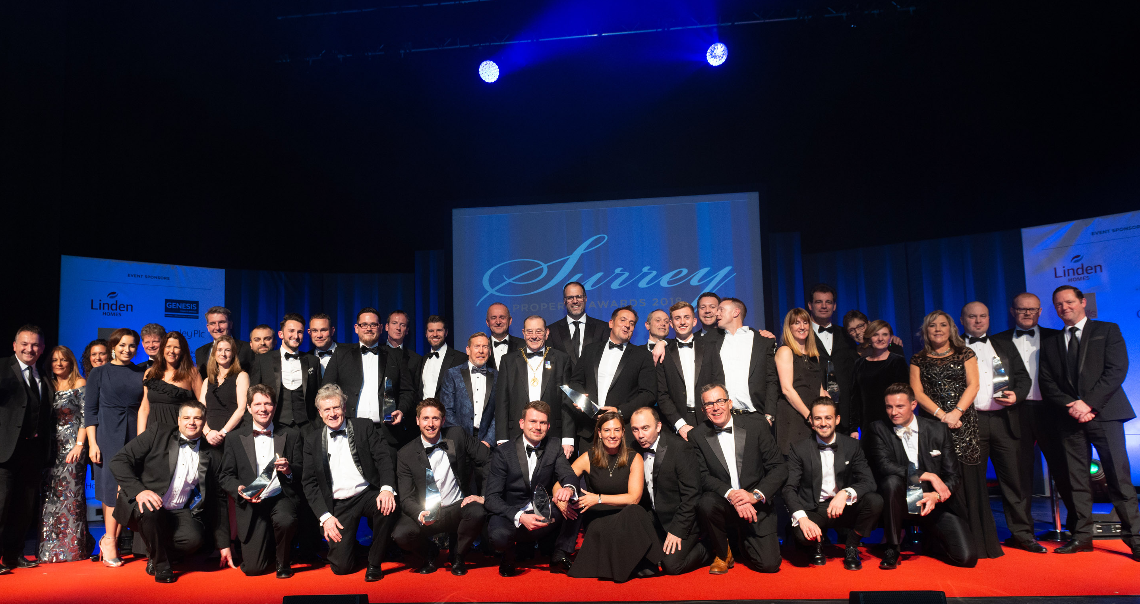
The 2018 Winners’ Line-up

A NIGHT OF SUCCESS, GLITZ AND GLAMOUR
AT THE 2018 SURREY PROPERTY AWARDS
Property professionals from all over Surrey assembled on 22nd November for the 2018 Surrey Property Awards and Gala Dinner. In the company of the Mayor and Mayoress of Guildford, guests were thoroughly entertained by rugby legend - and more recently Celebrity Masterchef finalist - Martin Bayfield, before the proud winners walked the red carpet to collect their trophies.
This incredibly popular occasion was attended by over 420 property professionals from throughout Surrey and Jacqueline West Managing Director of The Promotional Edge commented, “Weeks in advance we had to open a waiting list as all the places had been sold. This, together with the high level of attendees endorses the massive appeal of the awards and just how much the county’s property professionals embrace a regional event that provides companies of all sizes with an opportunity to compete fairly. I am also incredibly proud to announce that over the past nine years the awards has raised over £200,000 for children’s charities, and I’d like to personally thank those who donate auction items and those who bid for the myriad of super prizes.”
Martin Bayfield proved to be a huge success, presenting the winner of the raffle with a luxury break and wine tasting at Tinwood Vineyard near Goodwood, following a very entertaining after dinner speech, which included some hilarious anecdotes from his rugby days.
As testament to the increasing success of The Surrey Property Awards, 2018 included a high profile group of very generous sponsors: Savills, Linden Homes, Genesis Town Planning, Gateley Plc, the SBID (Society of British and International Design), Premier Magazine, Charles Russell Speechlys, Peter Krelle Associates, Bramley Blinds, MoveTo and media partner the Surrey Advertiser. All the official photography was by Huw Evans and the filming by Horizon Imaging. The film will be available to view at www.thepromotionaledge.co.uk from Monday 3rd December.
A new award for 2018, was the Best Interior Design category, which attracted nominations from across the county. The category was judged by the SBID (Society of British and International Design) with the winner’s trophy presented by the President, Diana Celella, who commented on the incredibly high standard of design and remarked on the flair and creativity The L&C Company had embellished in their winning project.
In addition to the awards and black tie gala dinner, the event once again incorporated a silent auction offering a diverse selection of prizes, ranging from a day on the Solent on a luxury cruiser to two tickets for the England v Australia match at Twickenham, with all the proceeds going directly to the nominated charity Challengers.
The event is recognised as the largest of its kind outside London and is a magnet for Surrey’s property companies and with 2019 being the award’s tenth anniversary, the organisers are planning an unmissable evening! With an advance list of table bookings and a commitment from a number of high level sponsors in place, anyone interested in attending the 2019 awards is urged to book early.
The date for The Surrey Property Awards 10th anniversary celebrations has been confirmed as Thursday 21st November 2019, with the voting website opening in June 2019. Please contact the organisers, The Promotional Edge T: 01483 233108 for further information.
2018 AWARD Winners
Best Marketing Campaign - Leaders Romans
Best Interior Design Project – The L&C Company for a Private Client project in Virginia Water
Best Residential Sales and/or Lettings Agent, Single Office - Swans
Best Residential Sales and/or Lettings Agent, 2-3 Offices - Ralph James
Best Residential Sales and/or Lettings Agent, 4+ Offices - Patrick Gardner
Best Commercial Agent/Chartered Surveyor - Vail Williams
Best Professional Property Services Company - Savills
Best New Homes Development, 1-12 Properties - Maplewood Place by Earlswood Homes
Best New Homes Development, 13+ Properties – Amlets Place by CALA Homes
Best New Luxury Property or Conversion – No 3 Staplands Manor by Vanderbilt Homes
Best New Apartment Development –Sondes Place by Twist
Property Professional of the Year – Luke Cole from Surrey Estates
ENDS:
Editor’s note: for further press information contact Jacqueline West at The Promotional Edge on 01483 233108 or jacqueline@thepromotionaledge.co.uk

